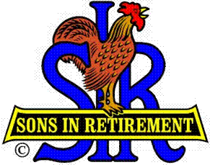

Las Trampas Branch 116

Executive Committee Meeting Agenda

November 20, 2017
9:30 AM
- Call Meeting to Order and confirm we have a quorum.
- Review Agenda/Minutes for Changes/Additions.
- Standing Reports:
Secretary – Fred Schafer – Approval of October 16, 2017 minutes
Attendance – Sam Beret
Head count, missed luncheon receipts
Membership – Phil Goff
New Members to be inducted:
Guests Today:
Visitors:

- Budget – Jim Nickles

- Big Sir Report:
- Storyteller: Paul Ramacciotti
- Chaplain: Art Donaldson
- HLM Award and Senior SIR Awards.
- Letter to New Member Wives
- Thanks for the Memories

- Little Sir Report:
- November Speaker: Jim Darby – Muzuno/Easton Sports
- Other

- Other Reports

- Adjourn – 10:15 am

